

Incentive Login User and Acquirer Maintenance



Version Control

|  |  |  |  |  |
| --- | --- | --- | --- | --- |
| Version | Date | Reason | Prepared By | Approved By |
| 1.0 | 1-APR-25 | Initial Release | IncentiveSupport |  |

Contents

LOGIN 4

HOMEPAGE 5

FORGOT PASSWORD 5

USER MANAGEMENT 7

Add New User 7

Search User 12

Edit User 13

Delete User 14

USER LOGS 16

MANAGE ACQUIRER/ISO PAYOUT 17

ONUS ADD TIER 18

ONUS MANAGE PAYOUT RULES 21

Master list of registered and enabled acquirers 23

# LOGIN

* In login screen, user will enter User Id, Password and Captcha and click on login button.

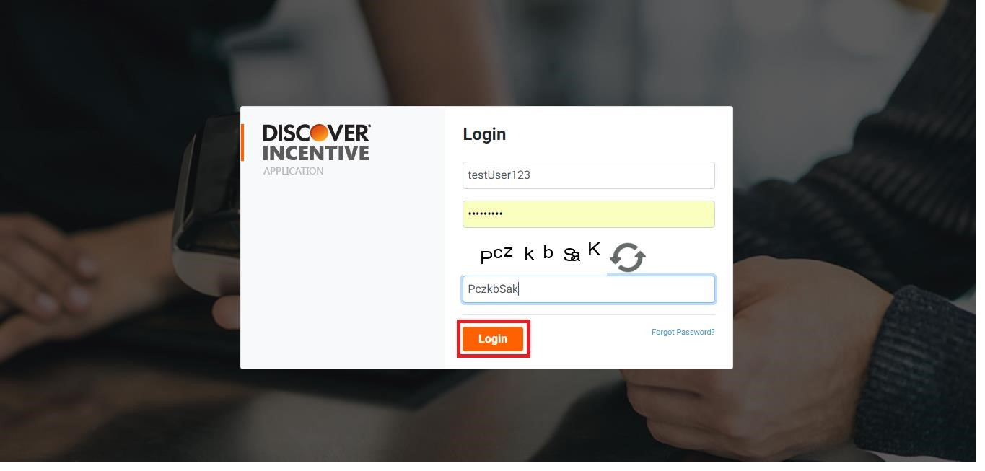

* If the user is Inactive/Deleted it will receive Invalid Credential.

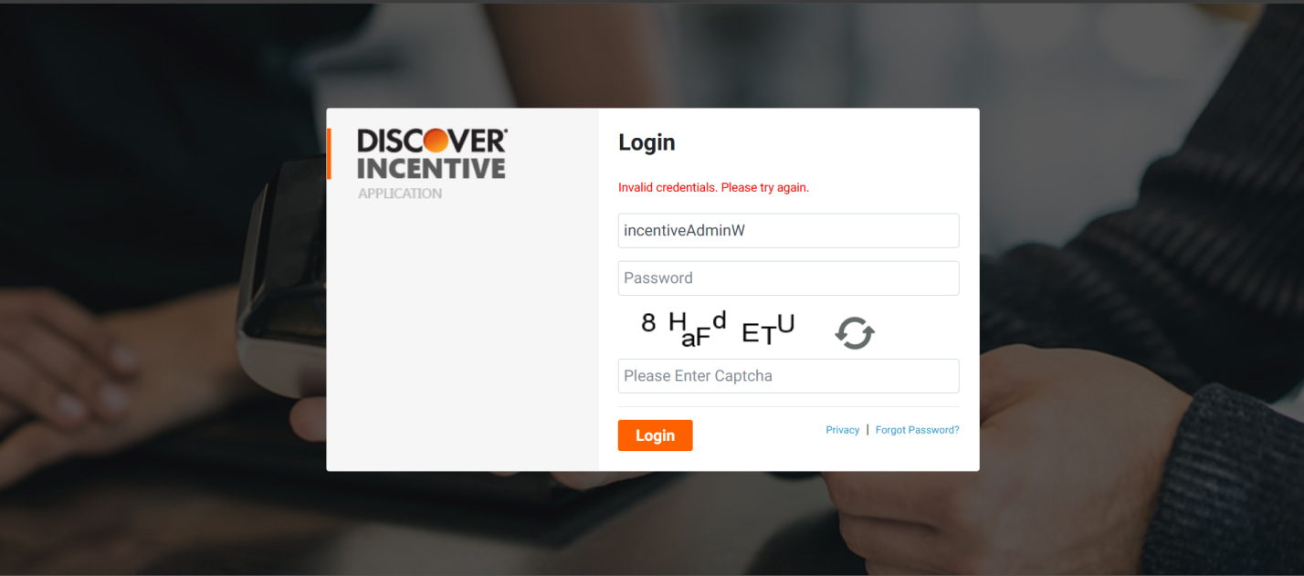

# HOMEPAGE

* On successful login, user will land to the Incentive Homepage as displayed below. User will have access to the OnUs, HIM programs as per their enrollment.

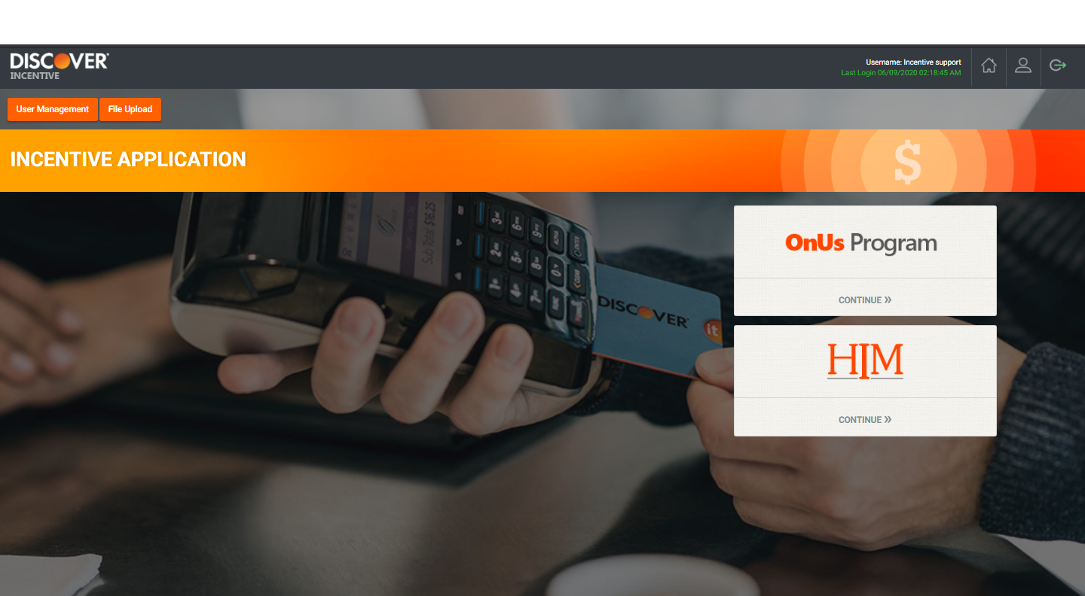

# FORGOT PASSWORD

* Click on “**Forgot Password**” link on Incentive Login Page to reset the password.

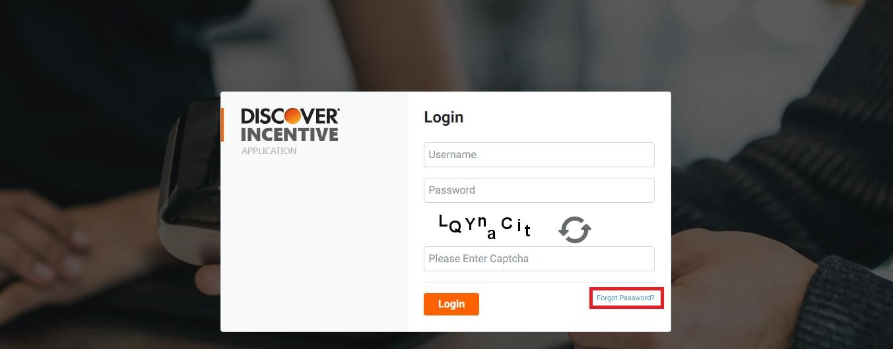

* User will enter the User Id and Captcha to reset the password and click on Submit button

.

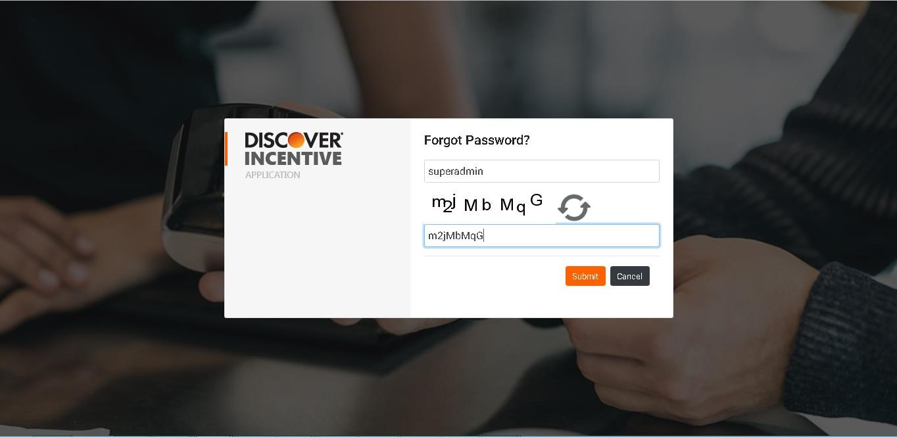

# USER MANAGEMENT

* Click on “**User Management**” option on Incentive Application Home screen to perform user related operations such as Add new user, Search user, Edit an existing user and Delete user etc.

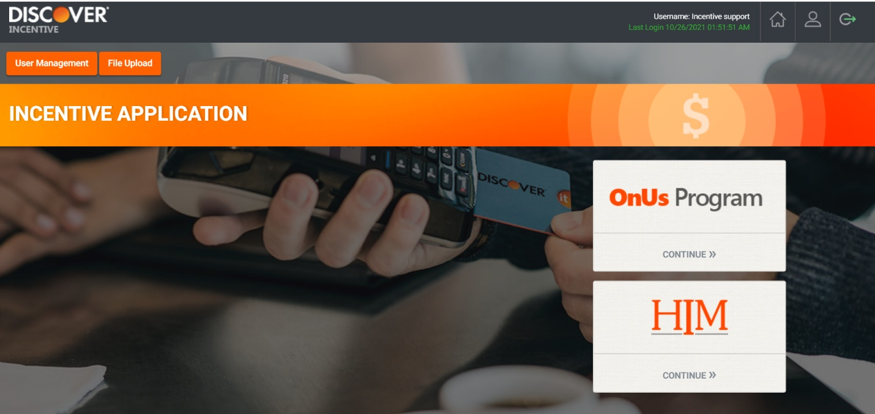

## 

## Add New User

To add a new user, we receive the request through appwise ticket or directly via email as below.

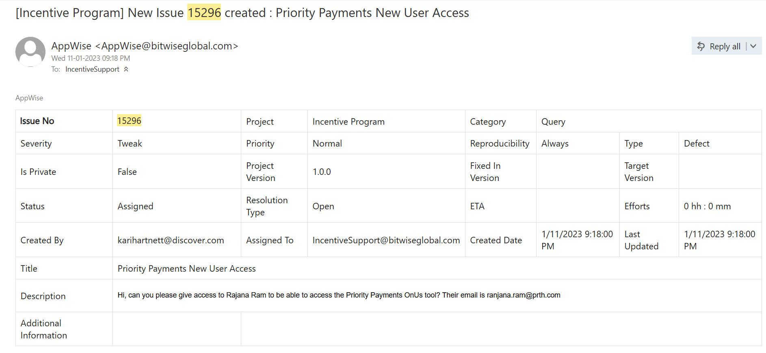

**Adding a new user for the first time to any of the program.**

* Click on **Add User** button to Add a new user to individual Program OnUs or HIM.

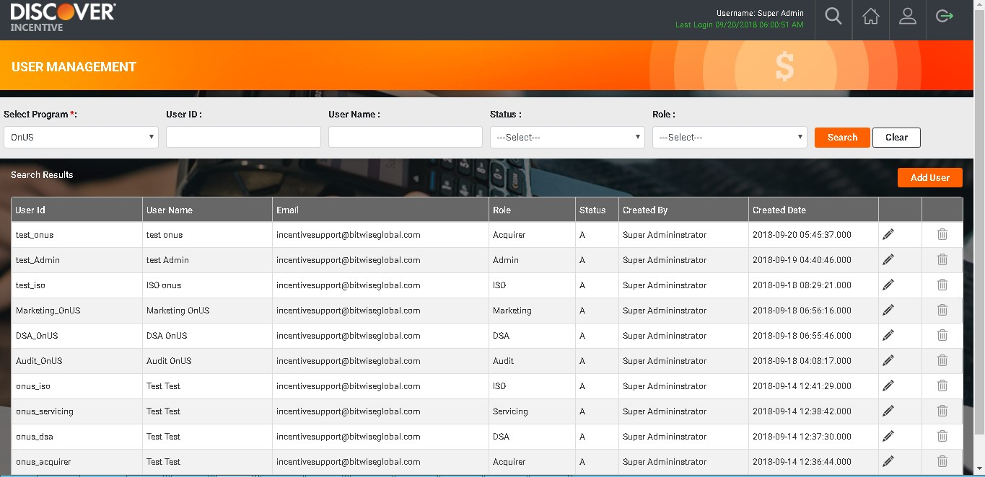

* User management on DB level

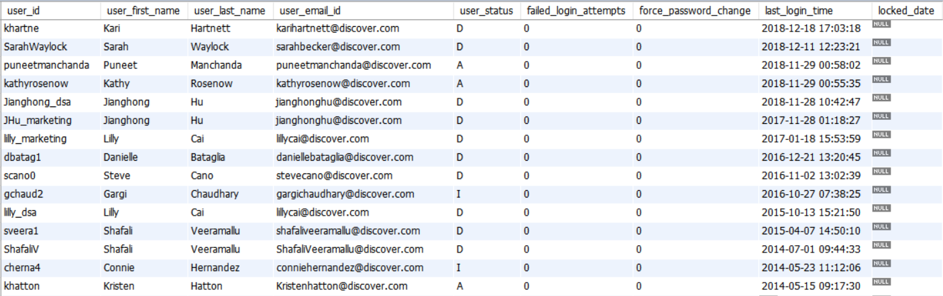

* After clicking on Add User button, below screen gets displayed

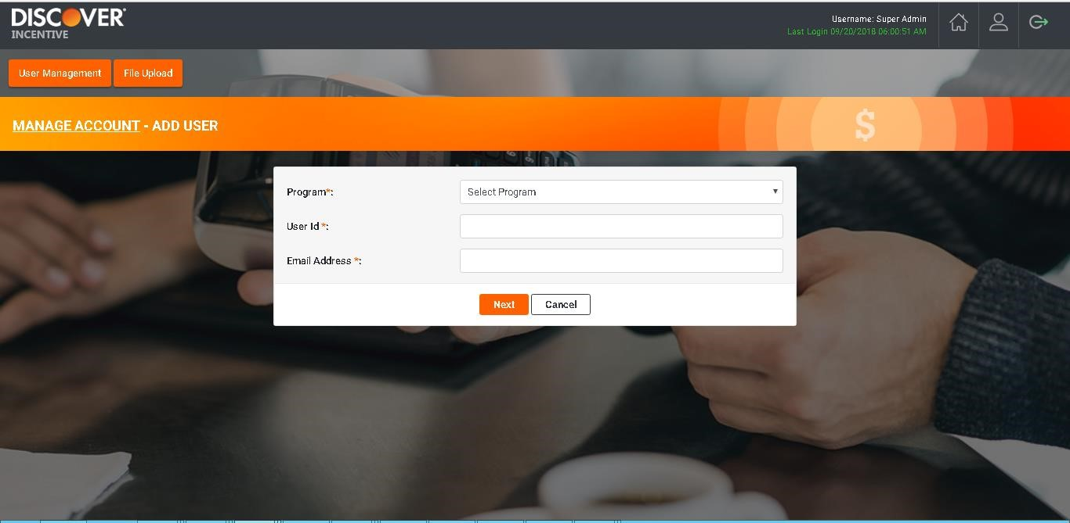

* Select the Program in which you want to add new user from the dropdown list.

Ex: If you wish to create a new user in OnUs Program, select OnUs from Program dropdown.

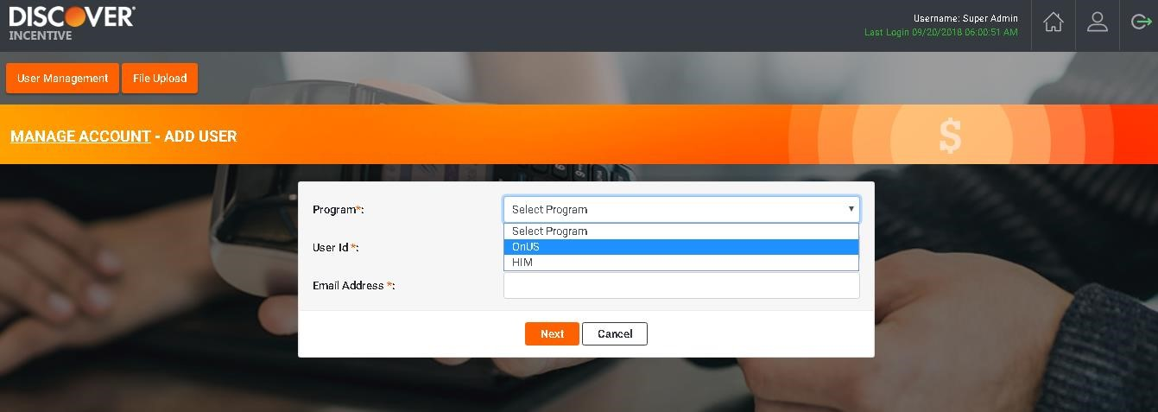

* Enter **User Id** and **Email Address** and click on Next option.

User Id and Email address fields are validated for their uniqueness. One User Id is associated with one email id. Users with existing User Id and registered email id will be allowed to add *in other programs*. But existing user with non-registered email id will be treated as duplicate user and tool will not allow them to enroll in any program.

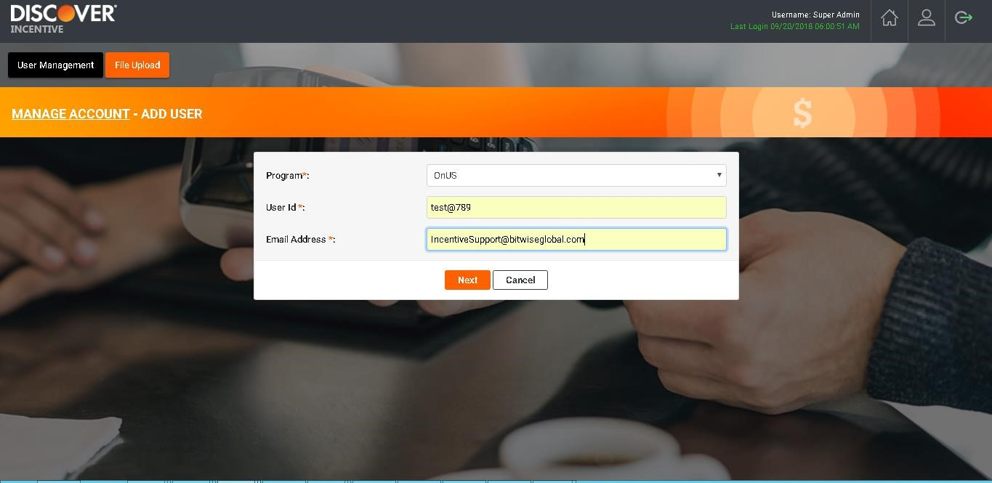

* On adding a user for the first time in any program, tool will ask user to enter Password and Confirm Password but while adding same user in any other program, these two fields will not be provided. User will enter all the details and click on Save button.

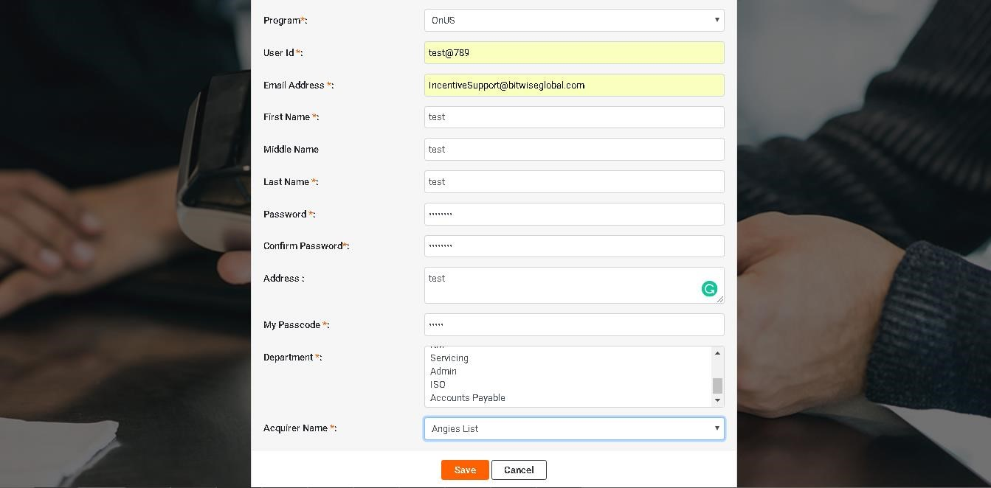

* User is successfully created and displayed under User management screen.

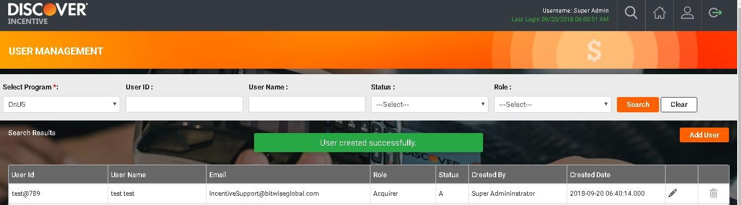

## Search User

* Select program where user is enrolled. Further user can use User Id, User Name, Status, Role to search user.

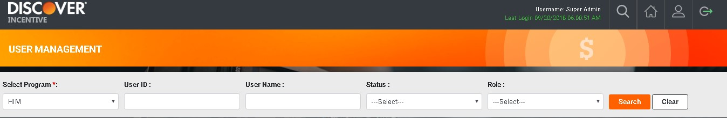

* After entering any of the fields in Search criteria, click on Search icon. Registered users will be displayed on screen if they are enrolled under selected program.

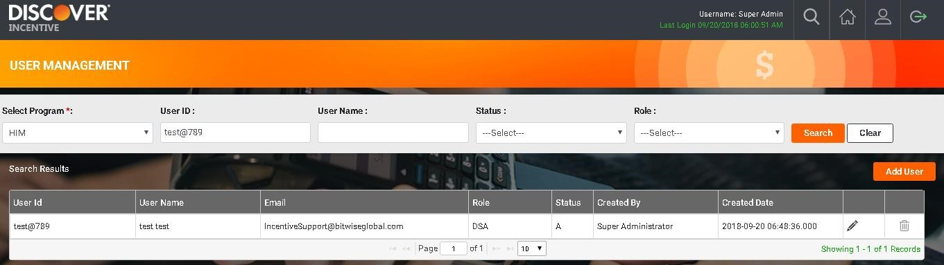

## Edit User

* To edit an existing user, search user in the Search criteria. You can see two icons. Click on **edit icon** as highlighted.

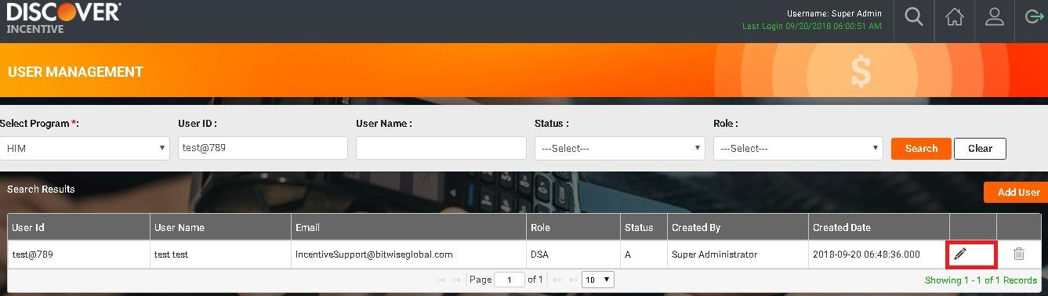

* Edit User screen will be displayed. You can edit the details and click on **Save** button.

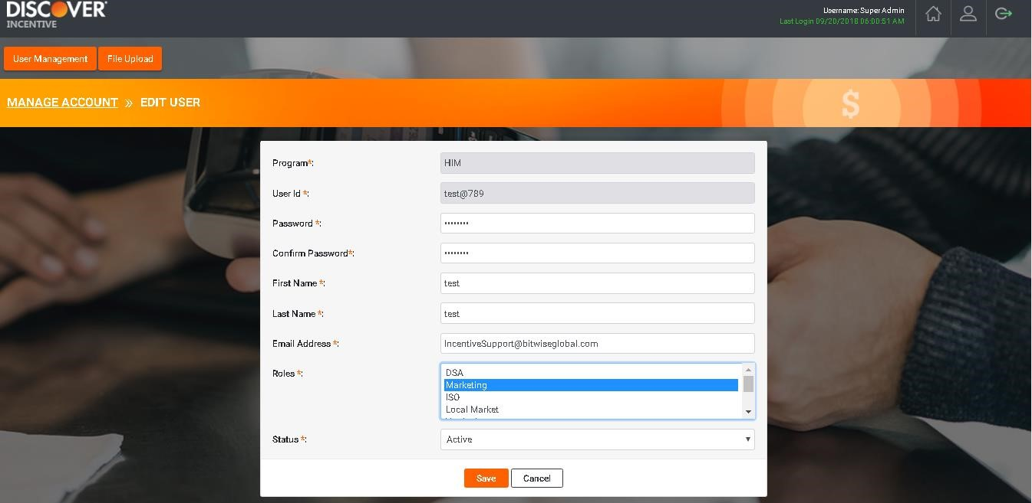

* User details will be saved and User Management screen will be displayed.

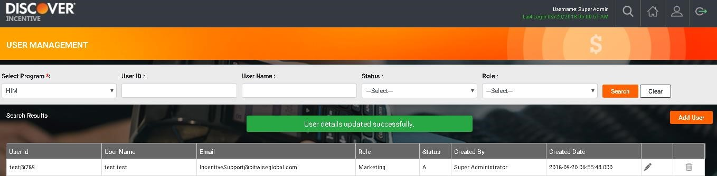

## Delete User

* We receive the user deletion request through Appwise ticket or email as below.

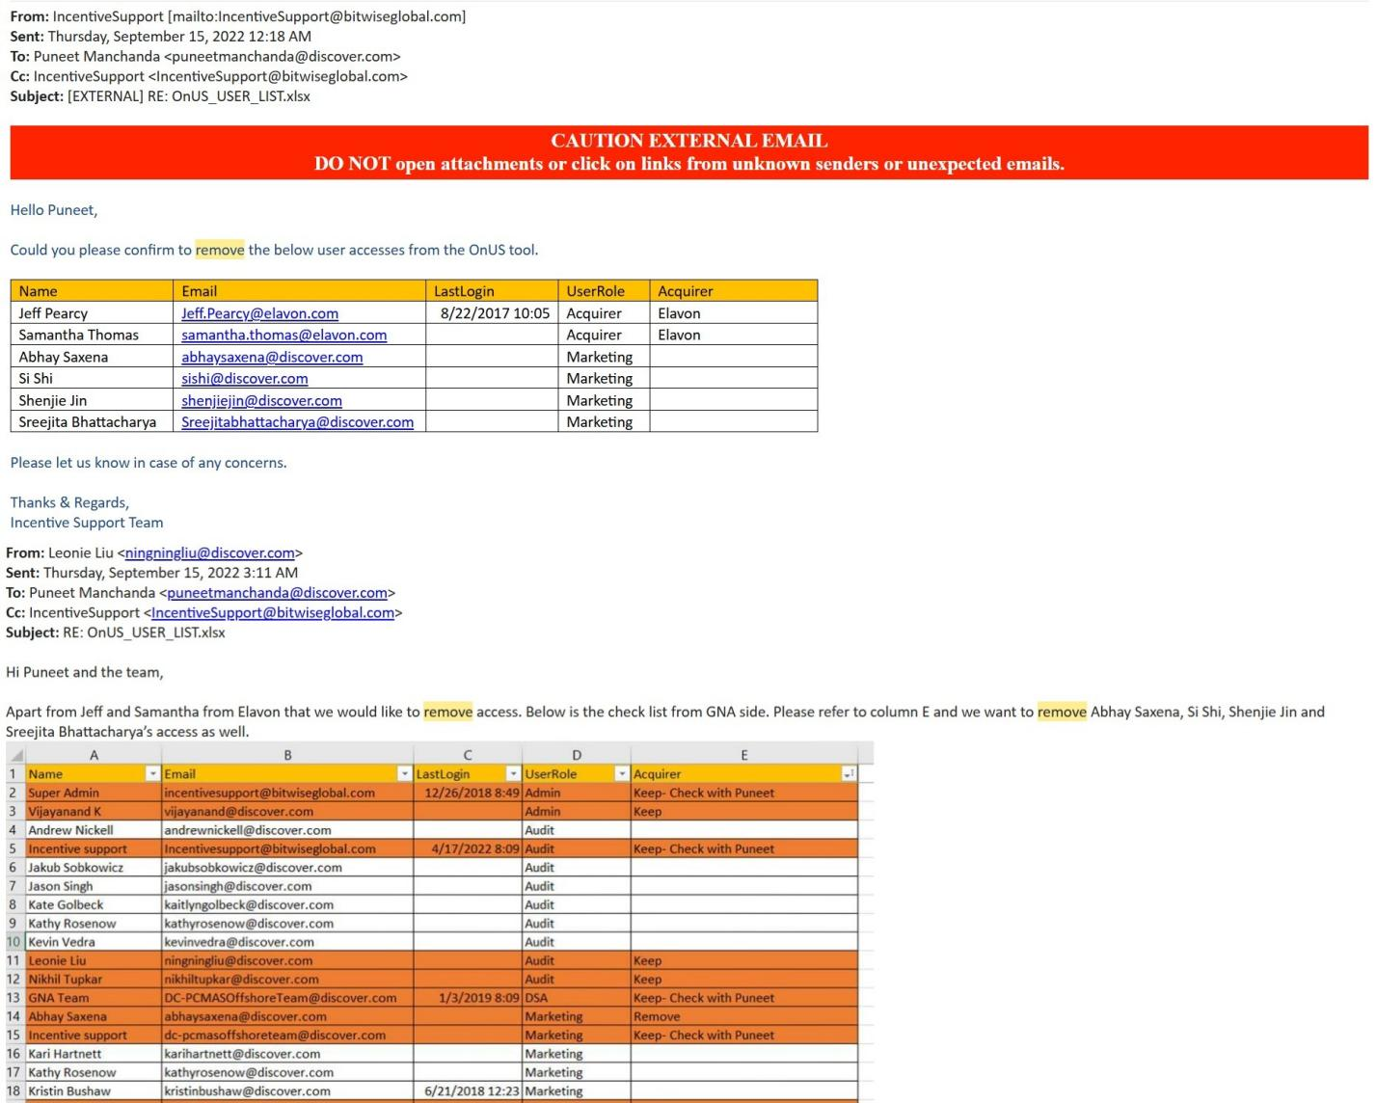

* To delete an existing user, search the user in the Search criteria. You can see two icons. Click on **delete icon** to delete the user.

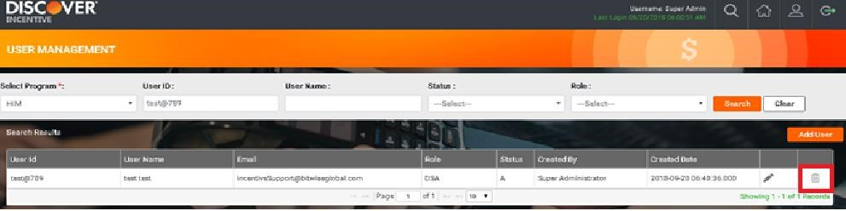

* A confirmation dialog will pop-up whether to delete user or not. On clicking **Yes** button, User will be removed successfully from the selected program.

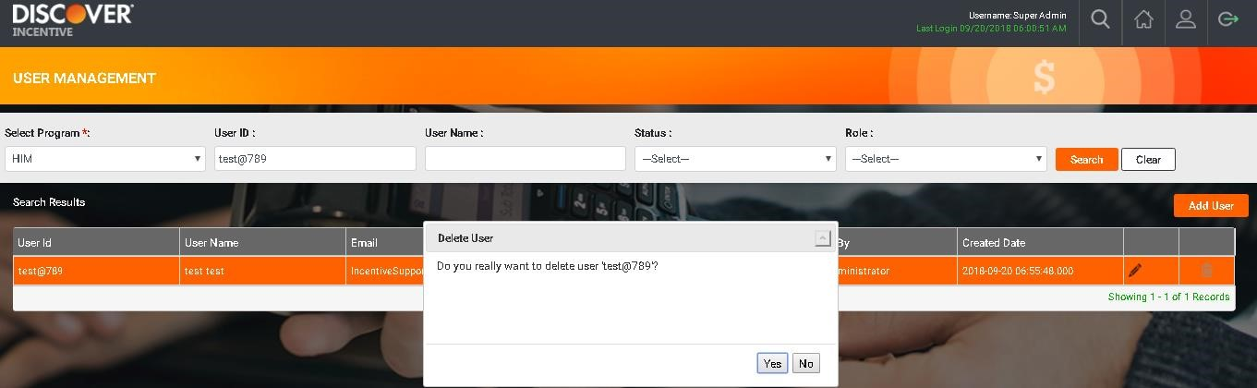

* User is deleted successfully from the program and User Management screen is displayed.

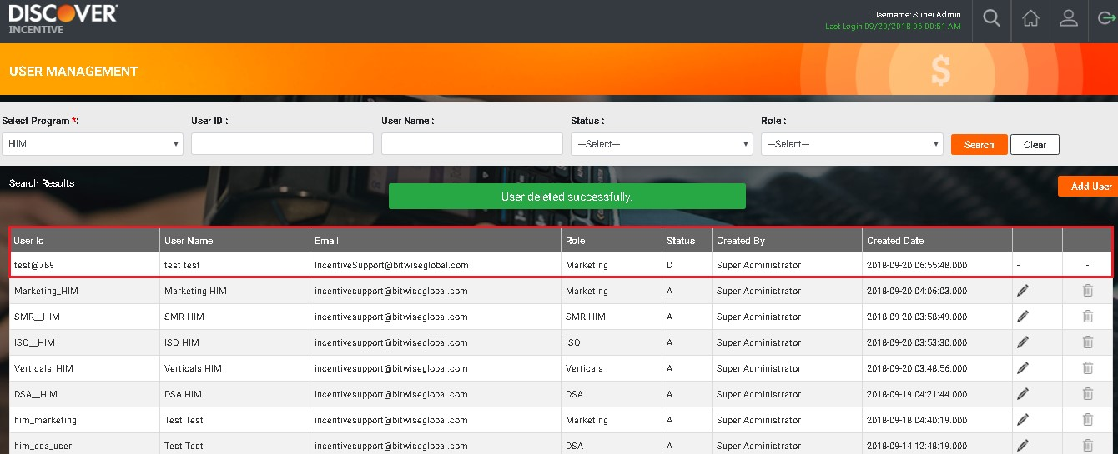

# USER LOGS

The tool has the Logs functionality with restricted access and have user logs (such as login, logout, file upload, report download) which are categorized with different filter.

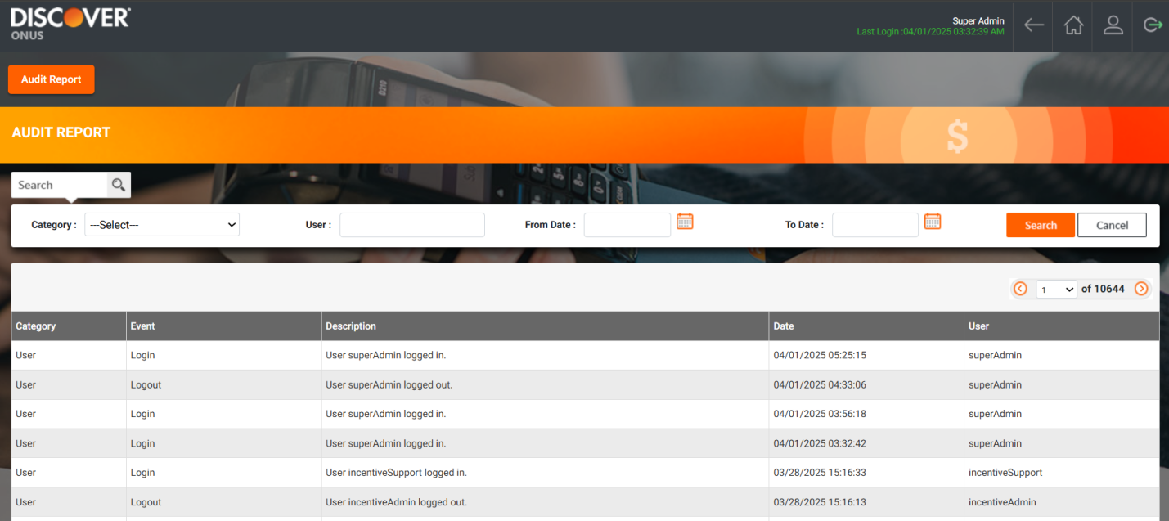

# MANAGE ACQUIRER/ISO PAYOUT

The tool has page to manage the acquirer/ISO Payout

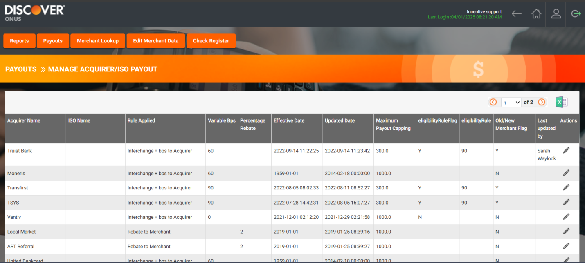

The DB Level view (Acquirer Table).

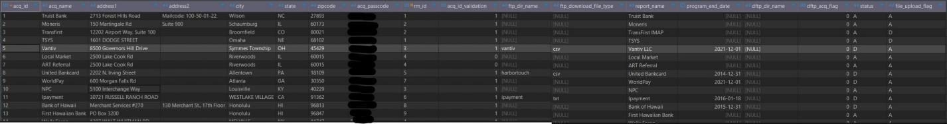

# ONUS ADD TIER

This functionality will let User add a new Tiers which will be used to display in Quarterly Payout report.

* On Incentive tool home screen, click on OnUs program icon to enter in to OnUs program

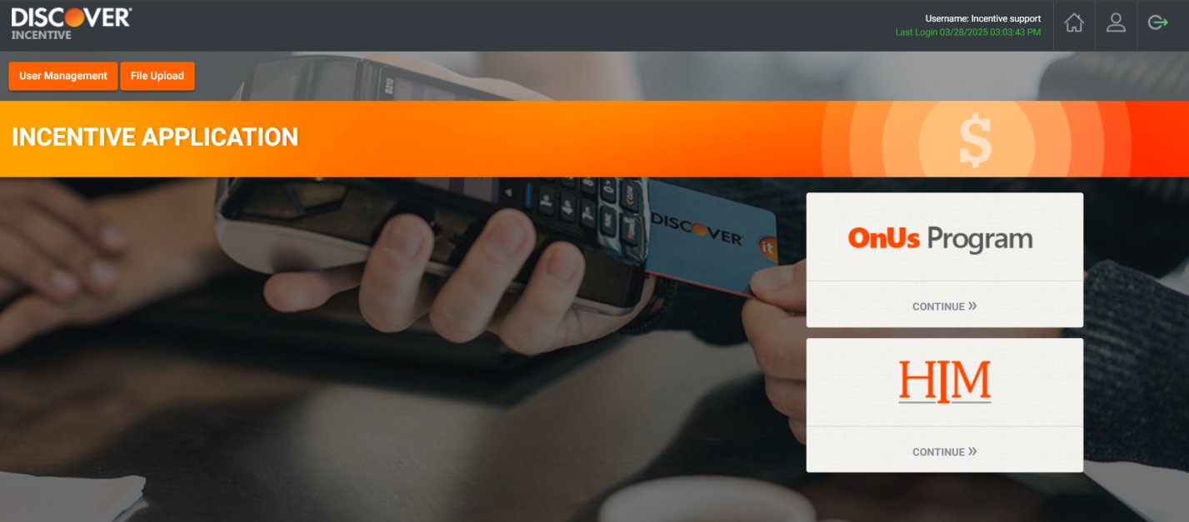

* Under Payout click on “Manage Payout Rules”

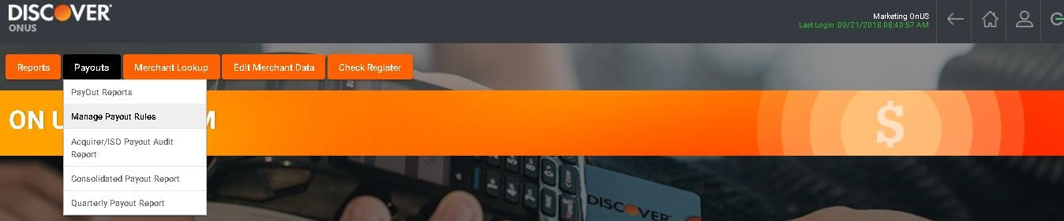

* List of Boarded Acquirers will be displayed. Click on “Edit” icon of Acquirer for which Tier needs to be added

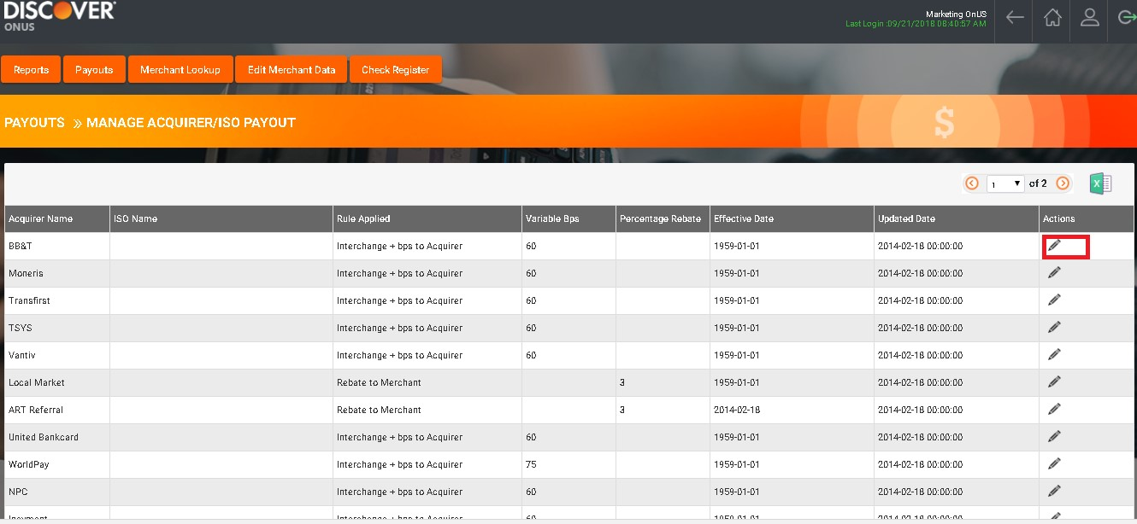

* Click on “Tier Maintenance” link

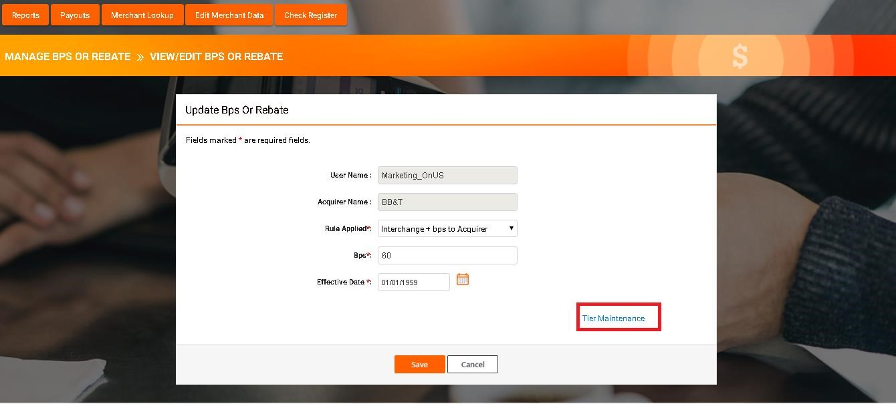

* Add Tier name, Min Capping and Max Capping.
* Click on Save button to Add new “Tier”
* Newly Added Tier will be displayed in data grid present on screen

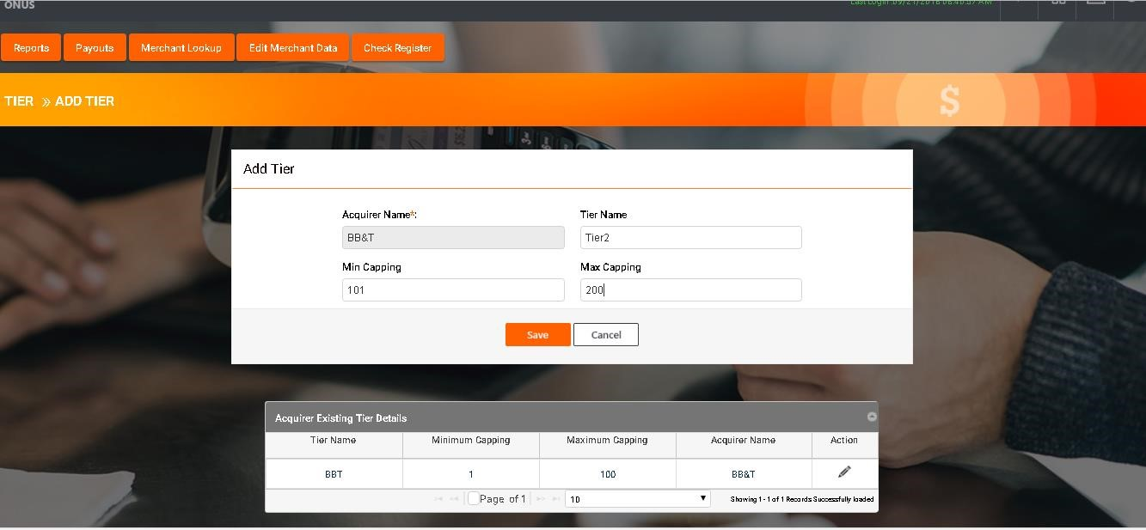

# ONUS MANAGE PAYOUT RULES

This functionality will let user add or modify Payout rule, BPS, Percentage Rebate, Merchant rebate capping and Maximum Payout capping amount.

* On Incentive tool home screen, click on OnUs program icon to enter in to OnUs program

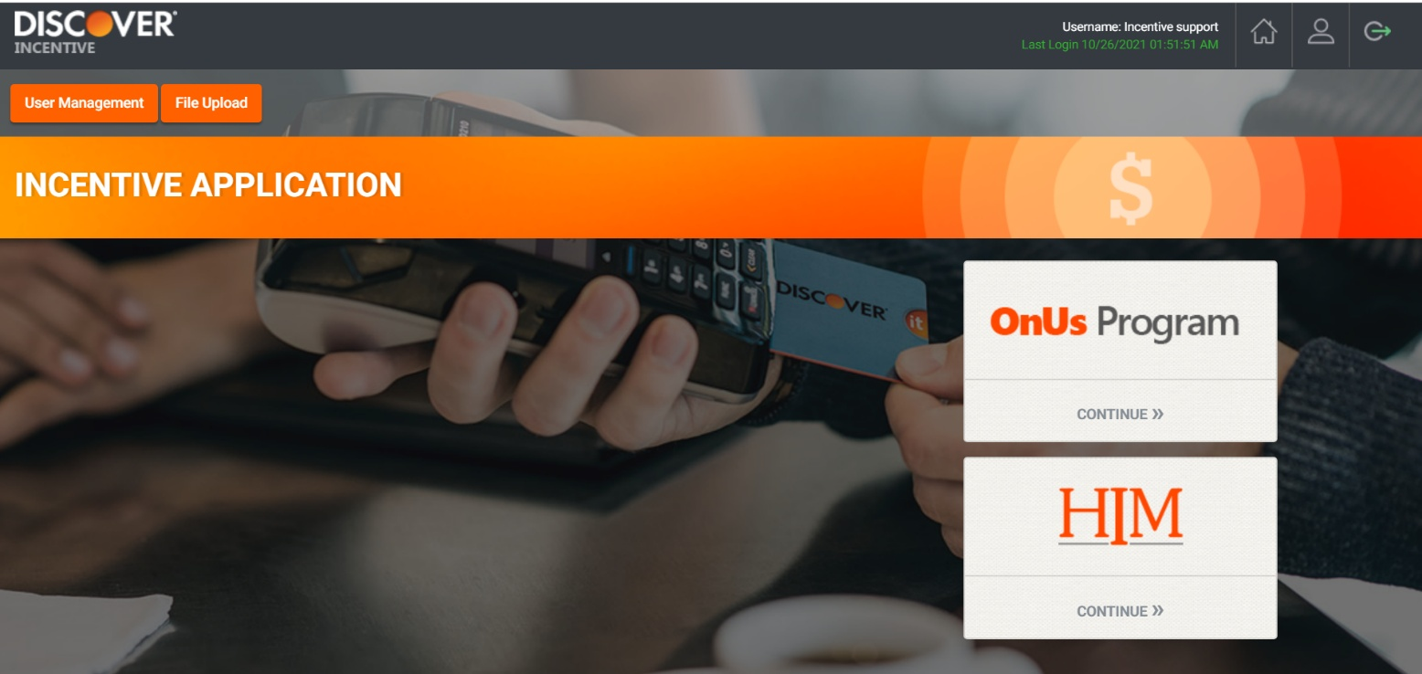

* Under Payout click on “Manage Payout Rules”



* Click on Edit icon in front of the Acquirer.

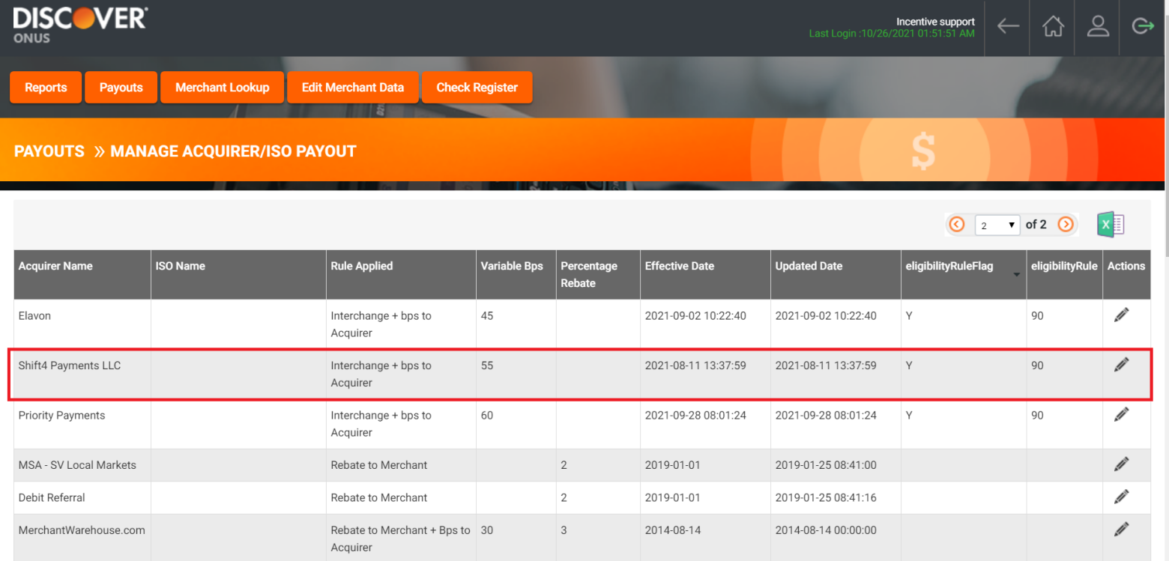

* User can edit eligibility rule/ 90D day rule on edit screen.
* Added checkbox on edit screen “Changes applicable to Old and New Merchants”, if this check box is checked, updated values will be updated for all payout rules exist for that acquirer.

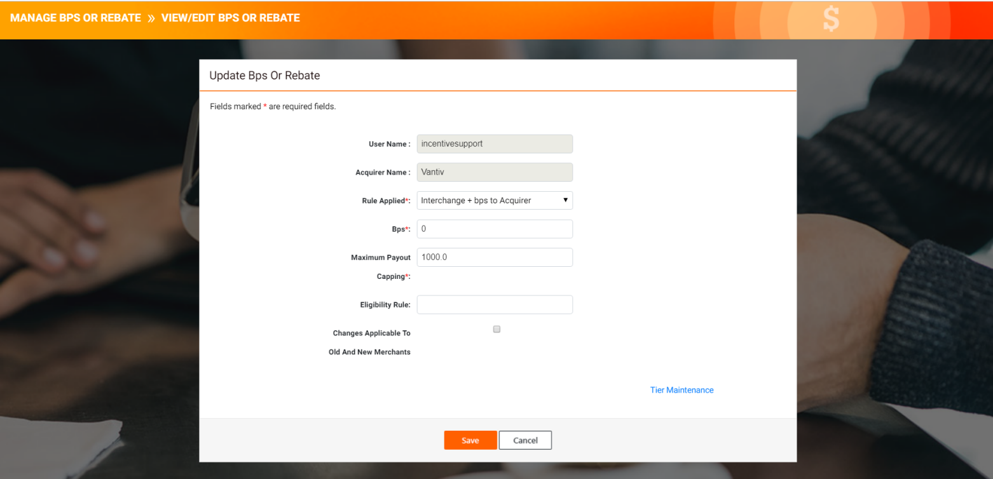

# Master list of registered and enabled acquirers

